Packet Tracer – Skills Integration Challenge

1. Topology

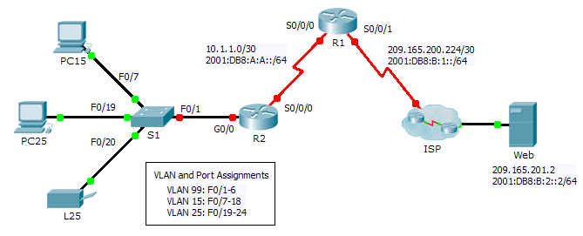

1. Addressing Table

|  |  |  |  |  |
| --- | --- | --- | --- | --- |
| Device | Interface | IPv4 Address | Subnet Mask | IPv4 and IPv6 Default Gateway |
| IPv6 Address/Prefix | |
| R1 | S0/0/0 | 10.1.1.2 | 255.255.255.252 | N/A |
| 2001:DB8:A:A::2/64 | | FE80::1 |
| S0/0/1 | 209.165.200.226 | 255.255.255.252 | N/A |
| 2001:DB8:B:1::2/64 | | FE80::1 |
| R2 | G0/0.1 | 192.168.1.193 | 255.255.255.224 | N/A |
| 2001:DB8:A:1::1/64 | | FE80::2 |
| G0/0.15 | 192.168.1.1 | 255.255.255.128 | N/A |
| 2001:DB8:A:15::1/64 | | FE80::2 |
| G0/0.25 |  |  | N/A |
| 2001:DB8:A:25::1/64 | | FE80::2 |
| G0/0.99 | 192.168.1.225 | 255.255.255.224 | N/A |
| 2001:DB8:A:99::1/64 | | FE80::2 |
| S0/0/0 | 10.1.1.1 | 255.255.255.252 | N/A |
| 2001:DB8:A:A::1/64 | | FE80::2 |
| S1 | VLAN 99 | 192.168.1.226 | 255.255.255.224 | 192.168.1.225 |
| PC15 | NIC | 192.168.1.2 | 255.255.255.128 | 192.168.1.1 |
| 2001:DB8:A:15::2/64 | | FE80::2 |
| PC25 | NIC |  |  |  |
| 2001:DB8:A:25::2/64 | | FE80::2 |
| L25 | NIC |  |  |  |
| 2001:DB8:A:25::A/64 | | FE80::2 |

1. Background

This activity allows you to practice a variety of skills including configuring VLANs, PPP with CHAP, static and default routing, using IPv4 and IPv6. Due to the sheer number of graded elements, you can click **Check Results** and **Assessment** **Items** to see if you correctly entered a graded command. Use the **cisco** and **class** passwords to access privileged EXEC modes of the CLI for routers and switches.

1. Requirements

**Addressing**

* The addressing scheme uses the 192.168.1.0/24 address space. Additional address space is available between VLAN 15 and VLAN 1. VLAN 25 needs enough addresses for 50 hosts. Determine the subnet and complete the subnet table below.

|  |  |  |  |
| --- | --- | --- | --- |
| VLAN | IPv4 Subnet Address | Subnet Mask | Hosts |
| 1 | 192.168.1.192 | 255.255.255.224 | 20 |
| 15 | 192.168.1.0 | 255.255.255.128 | 100 |
| 25 |  |  | 50 |
| 99 | 192.168.1.224 | 255.255.255.224 | 20 |

* Complete the **Addressing Table** by assigning the following addresses to VLAN 25:
  1. **R2** **G0/0.25** - First IPv4 address
  2. **PC25** - 2nd IPv4 address
  3. **L25** - Last IPv4 address
* Configure IPv4 addressing on the necessary end devices.
* On **R2**, create and apply IPv4 and IPv6 addressing to the G0/0.25 subinterface.

**VLANs**

* On **S1**,create VLAN 86 and name it **BlackHole**.
* Configure **S1** ports in static mode with the following requirements:
  1. **F0/1** is the native trunk for VLAN 99.
  2. **F0/7 - F0/18** as access ports in VLAN 15.
  3. **F0/19 - F0/24** as access ports in VLAN 25.
  4. **G1/1 - 2** and **F0/2 - F0/6** are unused. They should be properly secured and assigned to the **BlackHole** VLAN.
* On **R2**, configure inter-VLAN routing. VLAN 99 is the native VLAN.

**PPP**

* Configure **R1** and **R2** to use PPP with CHAP for the shared link. The password for CHAP is **cisco**.

**Routing**

* On **R1**, configure IPv4 and IPv6 default routes using the appropriate exit interface.
* On **R2**,configure anIPv6 default route using the appropriate exit interface.
* Configure IPv4 OSPF using the following requirements:
  1. Use process ID 1.
  2. Routers **R1** and **R2** are in area 0.
  3. **R1** uses router ID 1.1.1.1.
  4. **R2** uses router ID 2.2.2.2.
  5. Advertise specific subnets.
  6. On **R1**, propagate the IPv4 default route created.
* Configure IPv6 OSPF using the following requirements:
  1. Use process ID 1.
  2. Routers **R1** and **R2** are in area 0.
  3. Configure OSPF on appropriate interfaces on **R1** and **R2**.
  4. **R1** uses router ID 1.1.1.1.
  5. **R2** uses router ID 2.2.2.2.

**Connectivity**

* All devices should be able to ping the web server.